Use of PBBR for a Penaeus monodon maturation system

Trial-1
The activated Packed Bed Bioreactors were integrated into a maturation system operated at Private Hatchery. The maturation tanks were filled with 5-tonne 30ppt seawater. The bioreactor was operated at a flow rate of 400L/ hr. The tanks were stocked with 40 eyestalk ablated brooders with an average weight of 150 g. The animals were fed with clam, squid and crabs 3 times a day. The bioaugmentor Deterodigest and the gut probiotic Enterotrophotic were applied in to the system. Quantity of 100mL once in 3 days

Trial-2
Fifty-five adults of P. monodon were bought from a near by farm operated under closed system mode, negative to PCR for WSSV. Initially they were subjected for 7 days quarantine and on confirming that all animals were apparently healthy and consume feed, were stocked in the 10 tonne maturation tank.

Results and discussions

Penaeus monodon maturation system

Trial 1
Upon integrating the PBBRs into the maturation system, a stable nitrification was observed with a decrease in the TAN concentration 10-12 days after (Fig.1). From the 12th day onwards the TAN concentrations were found maintained below 1 ppm. During the establishment of first step nitrification, a gradual increase in the nitrite concentration was observed (Fig.2). However, two-step nitrification was established from the 23rd day onwards with the additional supply of 100 ml nitrite oxidizing consortia. Nitrate concentrations were always below 5 mg/L. Bacterial population enumerated on TCBS from the water samples were 30 CFU/mL during the initial days of experiment which gradually declined to zero at the end of the experimental period.

The pH and Alkalinity were maintained to a level of 7.8-8 and 120-140 respectively. The dissolved oxygen inside the reactors was always 5-6 mg/l .The salinity was maintained to 30 ppt.

Trial 2
Under this trial, fifty-five animals brought over from a culture pond turned out to be negative to WSSV and after a week’s quarantine they could be transferred to the maturation system safely and the performance of the reactor in maintaining the water quality was assessed. As summarized in Table 2, the system has attained a steady state situation with the establishment of two-stage nitrification. The residual ammonia nitrogen estimated in the rearing tank was around 0.1 PPM with no ammonia nitrogen in the incoming water. Nitrite was recorded almost zero. Animals are fed with a balanced diet consisting of clam/mussel, squid meat, polycheate worms and pelleted diet supplemented with vitamins. Under this condition, it was envisaged the animals would attain maturity within three months.

Recirculating systems for captive maturation and reproduction of penaeids remain relatively primitive. They depend upon a delicate balance of environmental parameters, eyestalk ablation and a relatively frequent replacement of broodstock, which is unscientific, and a diet of expensive fresh frozen feeds to maintain nauplii production levels. In the hatchery, problems with unexplained mortality and the presence of pathogenic bacteria continue to affect the stability of production and seed quality. Under such circumstances, the PBBR integrated into the maturation system provides great prospects in the water quality management in hatchery systems in general and in maturation systems in particular.

Days | Sample | TAN | NO₂-N | NO₃-N | pH | Alkalinity | Hardness
1 | Rearing tank | 0 | 0 | 4.11 | 7.82 | 135 | 7000
1 | Reactor Outlet | 0 | 0 | 5.17 | 7.77 | 135
2 | Rearing tank | 0.1 | 0 | 3.76 | 7.9 | 110
2 | Reactor Outlet | 0 | 0 | 3.64 | 7.8 | 100
3 | Rearing tank | 0.1 | 0 | 3.44 | 7.75 | 100
3 | Reactor Outlet | 0 | 0 | 3.23 | 7.6 | 100
4 | Rearing tank | 0.2 | 0 | 3.5 | 7.4 | 100
4 | Reactor Outlet | 0 | 0 | 3.7 | 7.29 | 100
5 | Rearing tank | 0.1 | 0 | 2.7 | 7.36 | 120
 | Reactor Outlet | 0 | 0 | 3.17 | 7.3 | 110
 | Fresh seawater | 0.3 | 0. | 0.1176 | 7.9 | 120 | 6000
Table.1. Nitrification in the Penaeus monodon rearing tank and the overall water quality compared to the fresh seawater.

Fig. 1. Nitrification in PBBR integrated Penaeus monodon maturation system

Fig. 1. Progress of nitrification in an integrated Penaeus monodon maturation system
(a)

(b)

Fig.2. (a) & (b.) :

Nitrification efficiency of the reactor integrated into a maturation system. Total Ammonia Nitrogen (TAN) and NO₂-N in the effluent were always below 0.1 ppm irrespective their influent strength. .(TAN in & NO₂-N in - in the incoming water to the reactor; TAN out & NO₂-N - in the out going water from the reactor.)

(b)
(c)

Fig.3 (a), (b) & (c). :
Ammonia removal by the reactors under varying substrate concentrations (a = 2 ppm, b = 5 ppm, c = 10 ppm)
(a)

(b)
(c)
Fig.4 (a), (b) & (c).
Nitrite removal by the reactors under varying substrate concentrations (a =2 ppm, b = 5 ppm, c = 10 ppm)
Fig. 5. Volumetric TAN removal rates by the reactor with flow rate
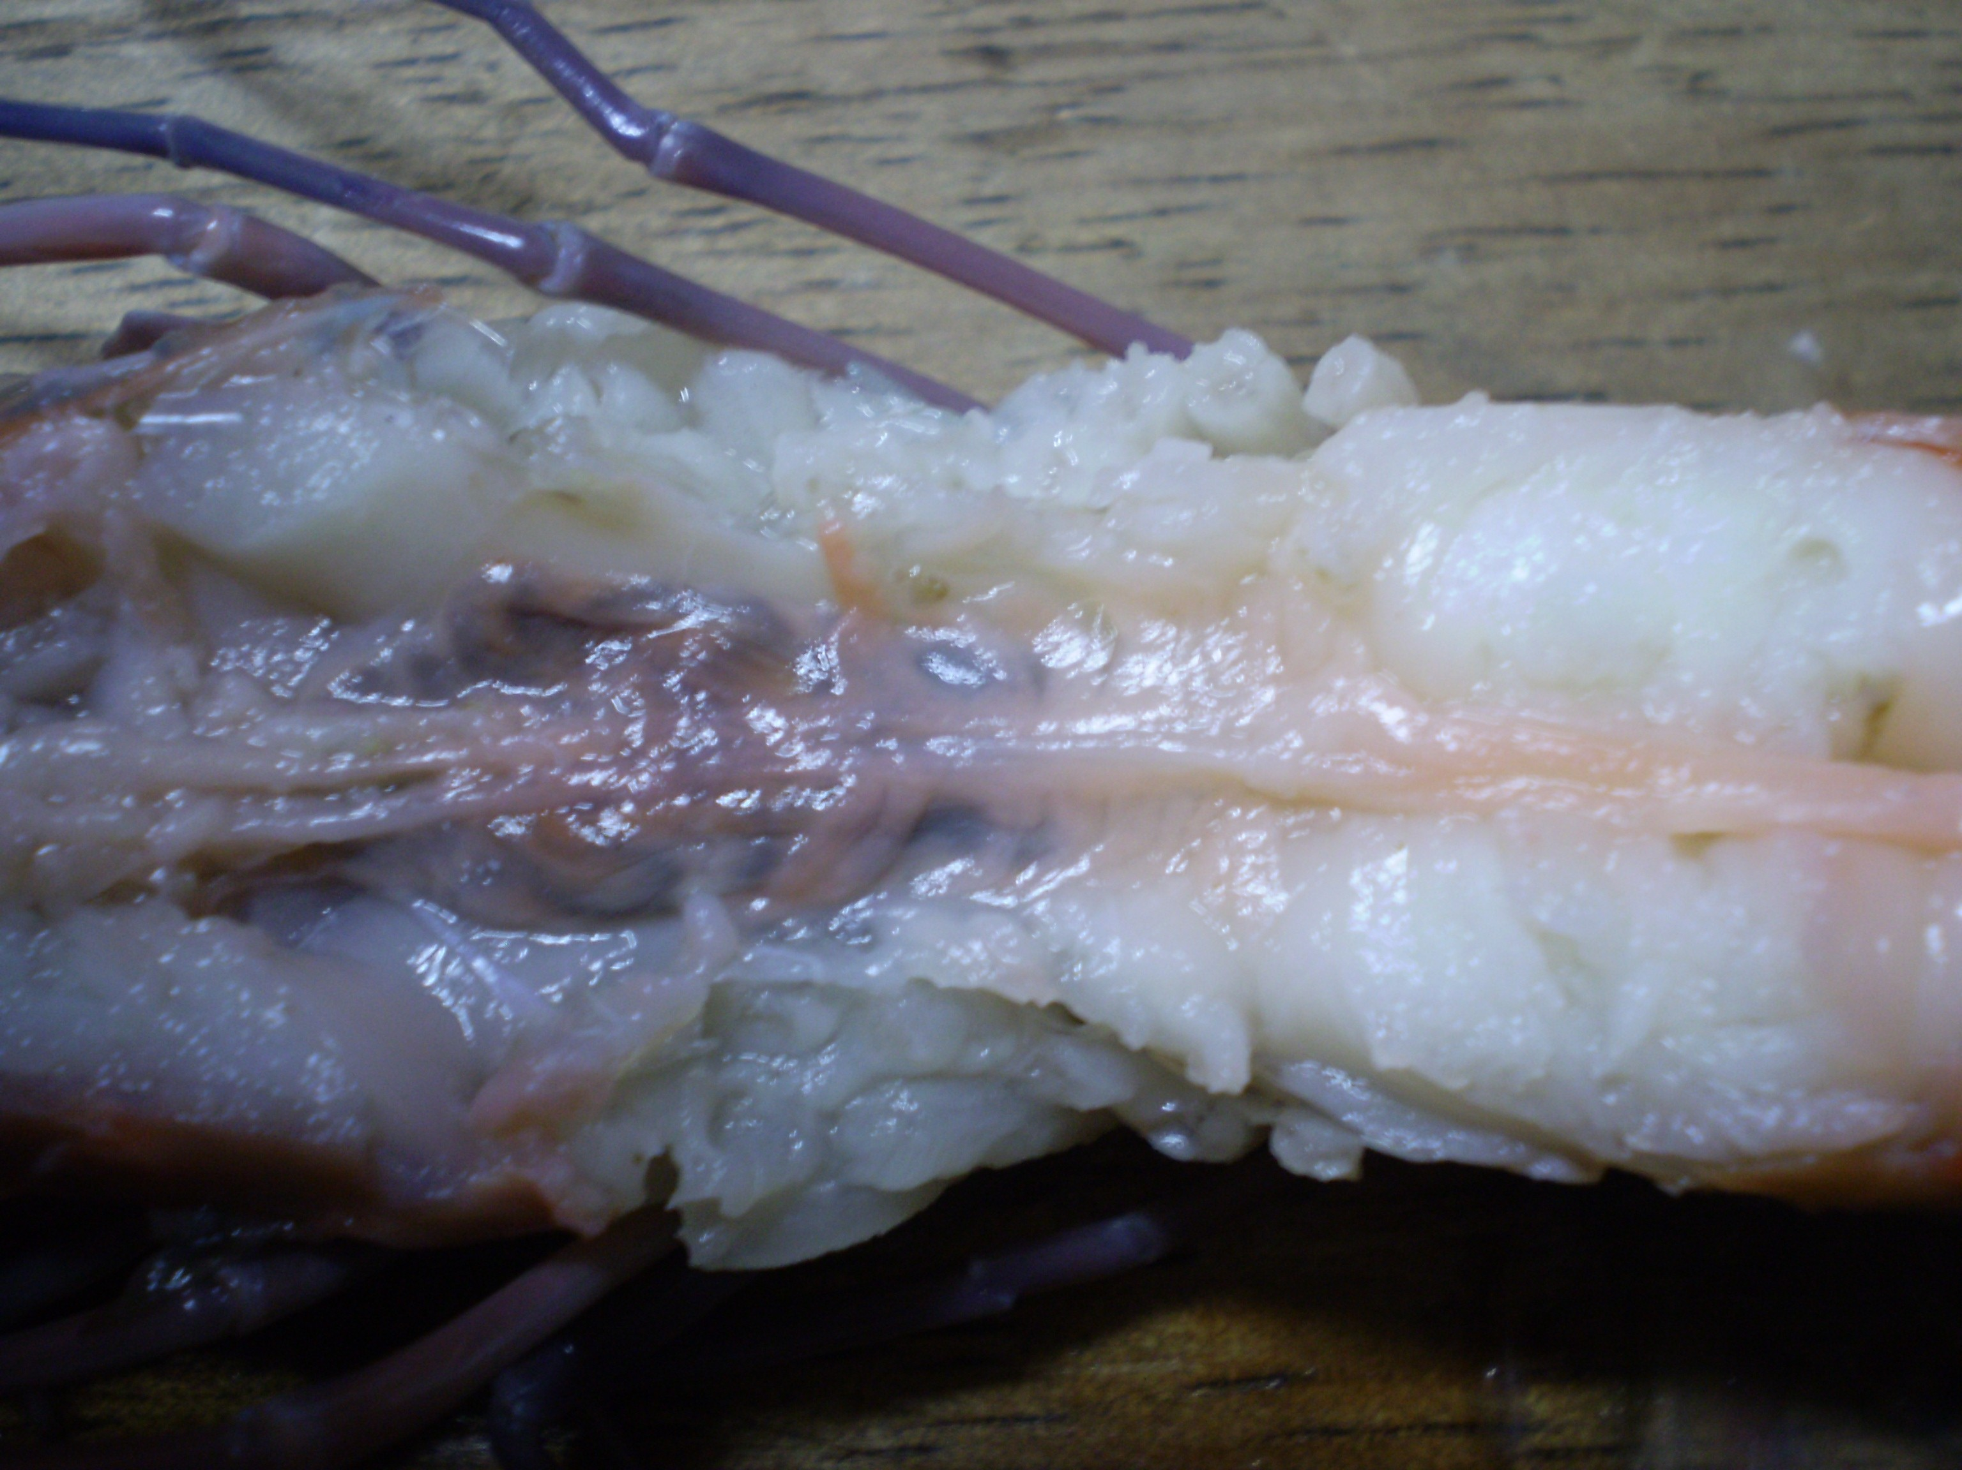
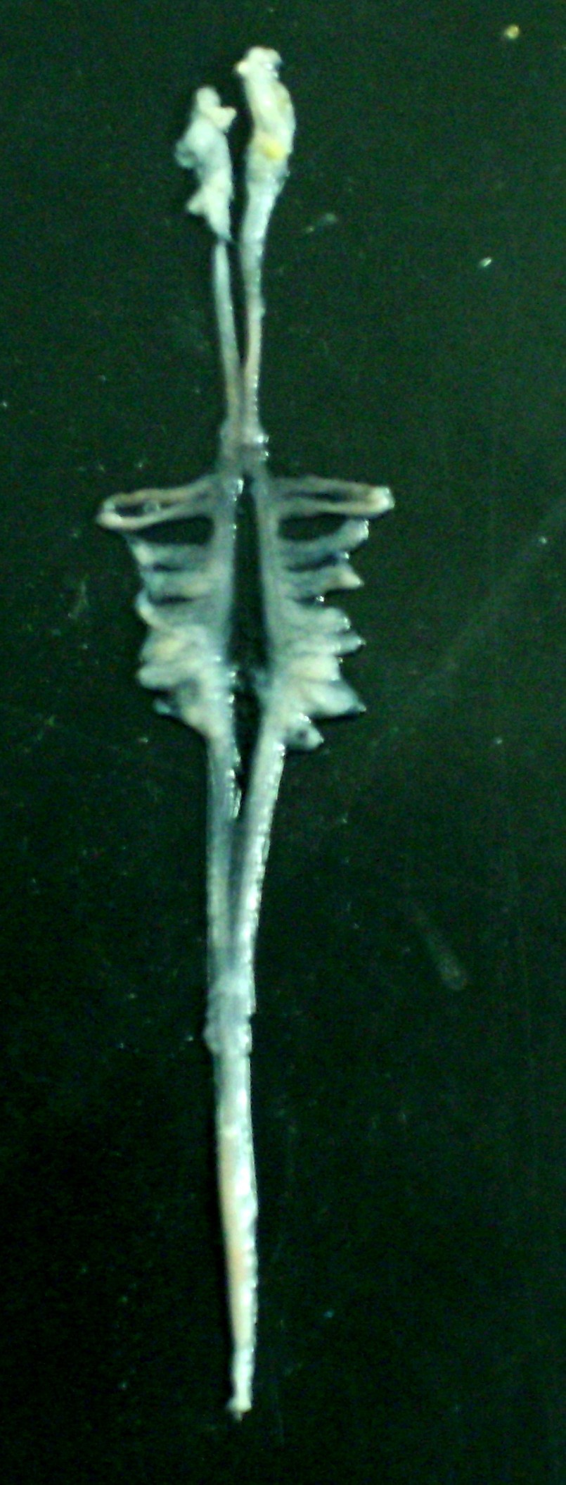

Fig 6 : Developing ovary in the animals reared in the Recirculating Aquaculture System
The summary of the findings from the field trials undertaken is given below:

- A shrimp (Penaeus monodon) maturation system was operational without any water exchange.
- The residual NH₄⁺-N estimated in the rearing tank was around 0.1 PPM.
- No ammonia nitrogen could be recorded in the outgoing water
- Nitrite was recorded almost zero
- Nitrate always stood below 7 ppm
- The bacterial consortium used for activating the reactors have denitrifying bacterial population also which further convert Nitrates to elemental Nitrogen.
- The bioreactor hereby achieves complete conversion of ammonia to nitrogen.
- When the substrate concentration in the incoming water goes up, the rate of consumption also has been found increasing to maintain the required steady state ammonia nitrogen in the system.
- Total vibrio stood within 30 - 50 cfu/ml.
- Ammonia consumption per reactor is 1 ppm / hr.
- Nitrite consumption per reactor is 2 ppm / hr.
- Peak removal of ammonia and Nitrites take place at the flow rate of 2500 Liters / hr giving a throughput of 60 tonnes / day.
- Figure 6 illustrates gonad's development in the animals. The conventional thinking is that animals cannot breed in captivity. However, in this study, almost all the animals were found with developing gonads.

